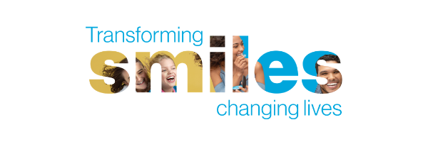
Join a team that is changing millions of lives.
Transforming smiles, changing lives

At Align Technology, we believe a great smile can transform a person’s life, so we create technology that gives people the confidence to take on whatever’s next. We revolutionized the orthodontic industry with the introduction of the Invisalign system, and we have never lost sight of that spirit of innovation. Our diverse and collaborative teams are constantly pushing the boundaries of what’s possible.

Ready to join us?

About this opportunity
Working as Junior 3D Planner / CAD Designer you will be creating the digital treatment plans for our clients in Europe from a technical, clinical and administrative point of view.
You will have a chance using the most advanced Invisalign® technology as well as have the opportunity to help our customers improve their smile and dental health.

In this role, you will…
- Creating digital treatment plans, tracking and analyzing prescriptions provided by the doctor (dentist), using our exclusive Clincheck software.
- Creating a high quality product that will provide the clinical effect expected by our patients, following the clinical instructions received from our dentist

In this role, you’ll need …
- Dental education background will be valued
- Digital skills, for working with computer tools
- CAD-CAM and/or 3D software support will be highly appreciated.
- Great interest in new technologies.
- Excellent communication skills at all levels.
- Very good English skills , any other European language will be valued

Sound like a good fit?

Great! Click the "Apply" link to let us know you are interested.
https://www.linkedin.com/jobs/search/?currentJobId=2350964474&f_C=6867&geoId=92000000&keywords=Junior%203D%20Planner

About Align

Align Technology is a publicly traded medical device company that is transforming smiles and changing lives. Our global team of talented employees develop innovative technology, tools and treatment options to help dental professionals worldwide achieve the clinical results they expect. Our digital ecosystem combines the power of technology to create beautiful smiles through the integration of AI and machine learning, digital imaging and visualization, biomechanics and material science to develop the Invisalign system, the most advanced clear aligner system in the world; iTero Intraoral Scanners and OrthoCAD digital services. Did you know? Align is the world’s largest manufacturer of custom 3D-printed materials.

By joining Align, you will be part of a global, fast-growing company in one of the most dynamic industries. Great people, innovative technologies, and meaningful work – these are just some of the things employees say make Align Technology a great place to work.

We respect your privacy. Please review our Applicant Privacy Policies for additional information.

Global Diversity Statement:
At Align, we believe in the power of a smile, and we know that every smile is as unique as our employees. As we grow, we will continue building a workforce of diverse cultural backgrounds and life experiences and fostering a culture of open-mindedness and compassion for all our employees. We live our company values by promoting healthy people and healthy communities. All with the intent of changing millions of lives, one unique smile at a time.

